LAB Logbook

Lab 1

Lab 2

Lab 3

Lab 4

Lab 5

Lab 6

Lab 7

Lab 8

**Model: "sequential_1"**

┏━━━━━━━━━━━━━━━━━━━━━━━━━━━━━━━━━┳━━━━━━━━━━━━━━━━━━━━━━━━┳━━━━━━━━━━━━━━━┓

┃ **Layer (type)** ┃ **Output Shape** ┃ **Param #** ┃

┡━━━━━━━━━━━━━━━━━━━━━━━━━━━━━━━━━╇━━━━━━━━━━━━━━━━━━━━━━━━╇━━━━━━━━━━━━━━━┩

│ lstm_1 (LSTM) │ (None, 27) │ 4,968 │

├─────────────────────────────────┼────────────────────────┼───────────────┤

│ dense_1 (Dense) │ (None, 2) │ 56 │

└─────────────────────────────────┴────────────────────────┴───────────────┘

**Total params:** 5,024 (19.62 KB)

**Trainable params:** 5,024 (19.62 KB)

**Non-trainable params:** 0 (0.00 B)

None

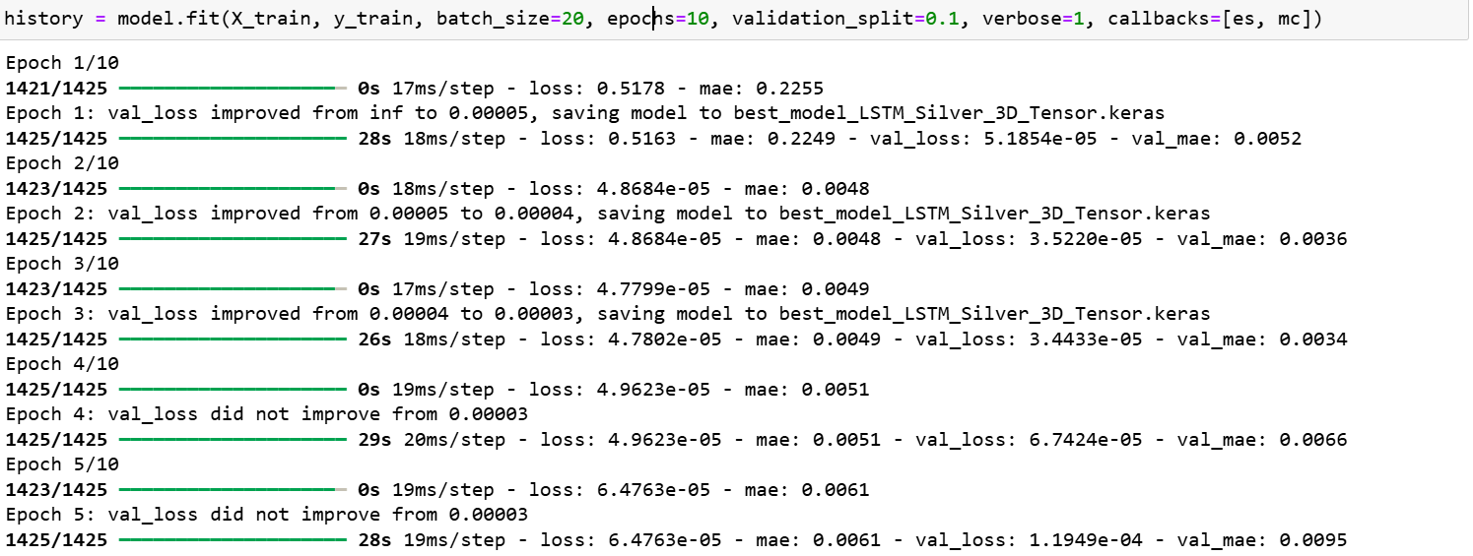

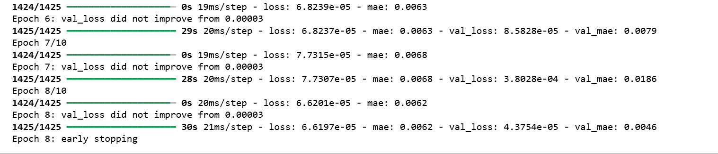

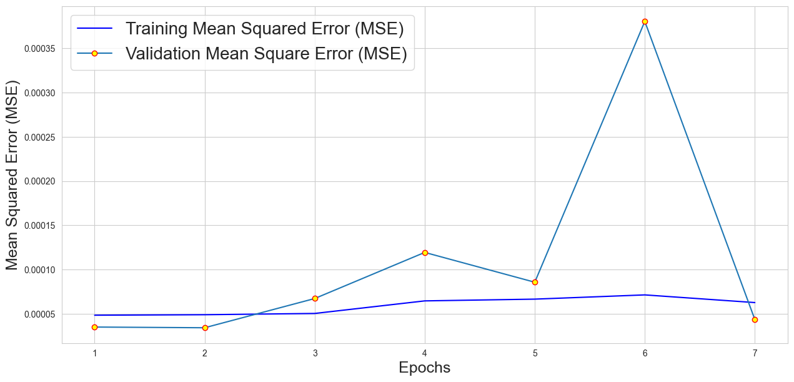

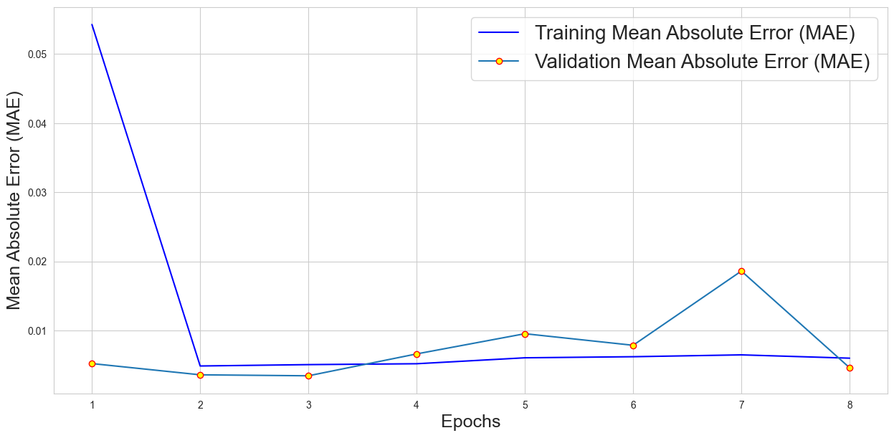

Lab 9

Lab 10

Lab 11

Lab 12